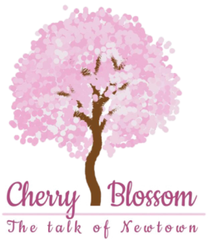

Find the alphabets from A – Z

- A right angle-
- Me-
- Add “A” and make a soup-
- Fourth in position-
- A beverage-
- Reverse of M-
- Attraction of the circus-
- Rita has, Sita does not-
- A question?-
- Stand in a line-
- “C” with a hook-
- Jane and Kite have in common-
- The leader-
- Comes in the middle of the sky-
- All of us-
- A career academy-
- Just before the beverage-
- Drink(in hindi)-
- Turn “Z” clockwise-
- Wrong-
- Gives you honey-
- Look-
- Apart of the ladder-
- Reflection of “W”-
- A full moon-
- A type of turn-

(Answers: L, I, F, D, T, W, J, Y, Q, G, E, A, K, V, Z, T, P, N, X, B, C, H, M, O, U)

