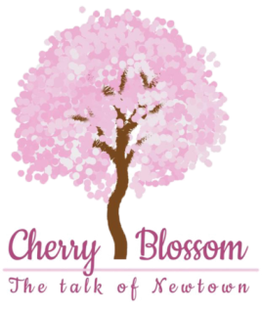

Name the logo:

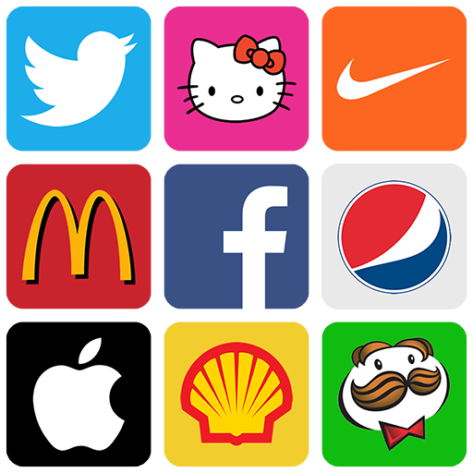

Answer: Twitter, Hello kitty, Niike, Mcdoland, Facebook, Pepsi, Apple, Pringles

