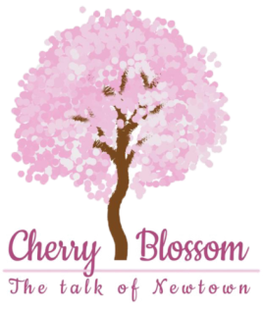

Riddles:

1)Where can you find cities, towns, shops and streets but no people?
2) What has a neck but no head?
3)What has hands but dosent clap?
4)What begins with an E but only has one letter?
5)What starts with a p,ends with an E and has thousands of letters?
6)What kind of tree can you carry in you hand?
7)What has 4 legs but cant walk?
8)I am an odd number. Take away one letters and I become even, what number am I?
9)Name 4 days of the week that starts with letter ‘T’ ?
10)What’s full of holes but still hold water ?
11)What word looks the same backward and upside down?

Answers:1)Map, 2) A bottle, 3) A clock, 4) An envelope, 5) Post office, 6) A palm, 7) A table, 8) Seven, 9) Tuesday, Thursday, Today and Tomorrow, 10)Sponge, 11) SWIMS

