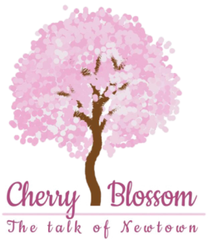

Guess the brand:
- I’m lovin’ it ___________________________
- Have it your way _______________________
- Just do it ______________________________
- Play.Laugh.Grow _______________________
- The happiest place on earth _______________
- Betcha can’t eat just once! _______________
- The ultimate driving machine _____________
- Eat fresh _____________________________
- The taste of India _______________________
- Eat healthy think better ________________
- It’s hot _____________________________
- Connecting people ___________________
- Be 100% Sure ______________________
- Made for each other __________________
- The Complete Man____________________
- Taste bhi health bhi ____________________
- Har ghar kuch kehta hai ________________
- Daag ache hai ________________________
- Desh ka namak _______________________
- Think different _______________________
Answers: 1) Macdonald, 2)Burger king, 3)Nike, 4)Fisher Price, 5)Disneyland, 6)Lays, 7)BMW, 8)Subway, 9)Amul, 10)Britania, 11)Radio Mirchi, 12)Nokia, 13)Dettol, 14)Wills, 15)Raymond, 16)Maggi, 17)Asian paints,18)Surf excel, 19)Tata salt, 20)Apple

